**MID SEM QUESTION_SEZG568 APPLIED MACHINE LEARNING EC 2R**

Q.

|  |
| --- |
| HR Department of your organisation want to classify job applications into good/bad categories, and to detect job applicants who lie in their applications using density estimation to detect outliers. How do you suggest to meet this requirement? Justify your suggestion in detail.            5M |
|  |

Q.

Consider any one of the following sectors. Identify a suitable application of Machine Learning algorithm and discuss the ML Pipeline.               5M

Medical Diagnostics / Defence /  Manufacturing / FMCG

Your need to mention the following in your answer

a) Application in the sector

b) Data related discussion

c) Suggested ML algorithm

Q.

Differentiate between linear classifiers implemented using linear regression and logistic regression. In this discussion consider the following             5M

Model      b) Objective function   c) Evaluation metrics

Q.

|  |
| --- |
| Suppose that we take a data set, divide it into equally-sized training and test sets, and then try out two different classification procedures. First we use logistic regression and get an error rate of 25% on the training data and 30% on the test data. Next we use Naïve Bayes classifiers and get an average error rate (averaged over both test and training data sets) of 15%. Based on these results, which method should we prefer to use for classification of new observations? Why?             5M |
|  |

Q.

iscuss the applicability of the following classifiers on the following data(given as scattered plot)      5M

Logistic Regression

Linear SVM

Linear SVM with Kernel

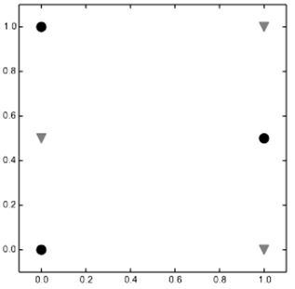

Q.

